A list of 100 fantastic reads!

Find below a list of great books! There should be something for everyone here, all mixed in together – a range of reads from classics to modern reads, sci-fi to romance, fantasy to non-fiction... Browse the titles, see which appeal to you, look up reviews, pick and choose what suits – don't expect to fall in love with every book on the list, but use it to help you find what you do like. Most of all, just have fun!
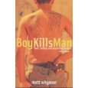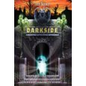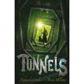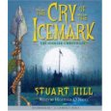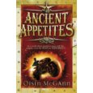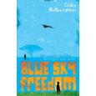
1. Boy Kills Man – Matt Wyman
2. Darkside – Tom Becker
3. Tunnels – Roderick Gordon and Brian Williams
4. The Cry of the Icemark – Stuart Hill
5. Ancient Appetites – Oisin McGann
6. Blue Sky Freedom – Gabrielle Halberstam
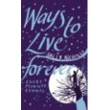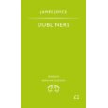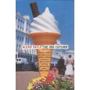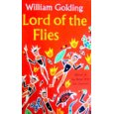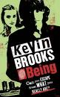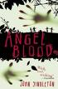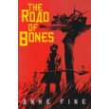
7. Ways to Live Forever – Sally Nicholls
8. Dubliners - James Joyce
9. The Dog Catcher - Alexei Sayle
10. Lord of the Flies – William Golding
11. Being – Kevin Brooks
12. Angel Blood – John Singleton
13. Road of Bones – Anne Fine

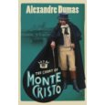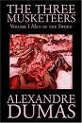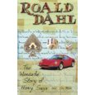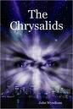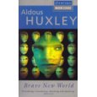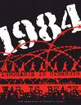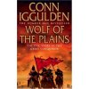
14. Count of Monte Cristo – Alexandre Dumas
15. The Three Muskateers – Alexandre Dumas
16. The Wonderful Story of Henry Sugar – Roald Dahl
17. The Crysalids – John Wyndham
18. A Brave New World - Aldous Huxley
19. 1984 - George Orwell
20. The Conquerer and Emperor series – Conn Igulden
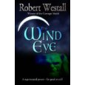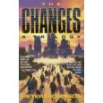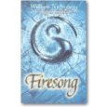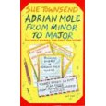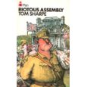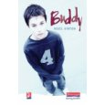
21. The Wind Eye - Robert Westall
22. The Changes: A Trilogy - Peter Dickinson
23. The Tripods trilogy – John Christopher
24. Wind on Fire trilogy – William Nicholson
25. The Adrian Mole books by Sue Townsend
26. Riotous Assembly - Tom Sharpe
27. Buddy – Nigel Hinton
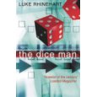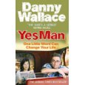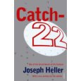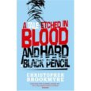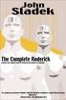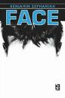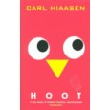
28. The Dice Man – Luke Rhinehart
29. Yes Man – Danny Wallace
30. Catch 22 – Joseph Heller
31. A Tale Etched in Blood and Hard Black Pencil - Christopher Brookmyre
32. Roderick - John Sladek
33. Face – Benjamin Zephaniah
34. Hoot – Carl Hiaason
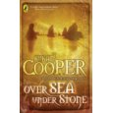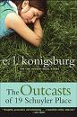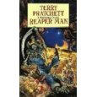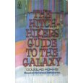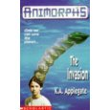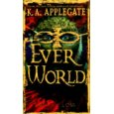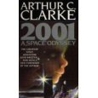
35. Over Sea, Under Stone – Susan Cooper
36. The Outcasts of 19 Schloer Place - E.L.Konigsburg's
37. The Discworld Series - Terry Pratchett
38. Hitchhikers Guide to the Galaxy - Douglas Adams
39. Animorphs series - K.A.Applegate
40. Everworld series - K.A.Applegate
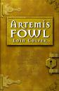41. 2001: A Space Odyssey – Arthur C. Clarke
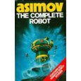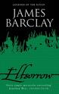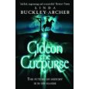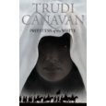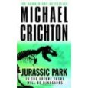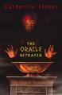
42. I Robot ; The rest of the Robots – Isaac Asimov
43. Legends of the Raven series – James Barclay
44. Archer Gideon Cutpurse - Linda Buckley
45. Age of the 5 trilogy - Trudy Canavan
46. Artemis Fowl series - Eoin Colfer
47. Jurassic Park - Michael Crichton
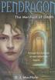48. The Oracle trilogy - Catherine Fisher
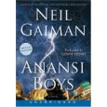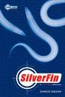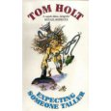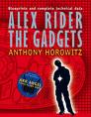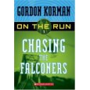49. Ananasi Boy - Neil Gaiman
50. Young James Bond series - Charlie Higson
51. Expecting Someone Taller - Tom Holt
52. Anthony Horowitz - Anything by this author!
53. On the Run series - Gordon Korman
54. Pendragon series - D.J. Mc Hale

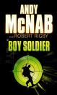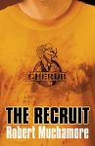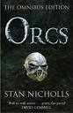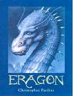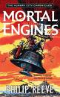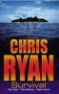
55. Boy Soldier series - Andy McNab
56. Cherub series - Robert Muchamore
57. Orcs - Stan Nicholls
58. Eragon triology - Christopher Paolini
59. Mortal Engines quartet - Philip Reeve
60. Code Red series; Alpha Force series - Chris Ryan
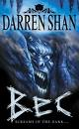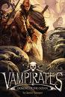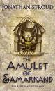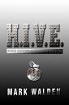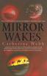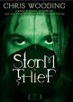
61. Darren Shan saga ; demonata - Darren Shan
62. Vampirates series - Justin Somper
63. Bartimaeus trilogy - Jonathon Stroud
64. H.I.V.E - Mark Walden
65. Mirror Wakes; Mirror Dreams - Catherine Webb
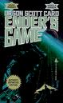66. Storm Thief - Chris Wooding
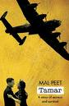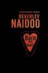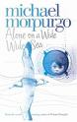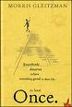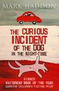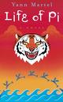
67. Ender's Game – Orson Scott Card
68. Tamar - Mal Peet
69. Burn My Heart - Naidoo
70. Alone on the Wide Wide Sea - Morpurgo
71. Once - Morris Gleitzman
72. The Curious Incident of the Dog in The Nighttime - Mark Haddon
73. The Life of Pi – Yann Martell
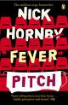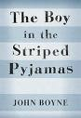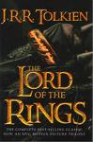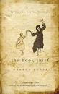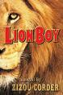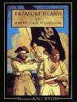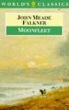
74. Fever Pitch – Nick Hornby
75. The Boy in the Striped Pyjamas – John Boyne
76. Lord of the Rings – J.R.R. Tolkein
77. The Book Thief – Markus Zusak
78. The Lion Boy trilogy – Zizou Corder
79. Treasure Island – Robert Louis Stephenson
80. Moonfleet – J. Meade Falkner
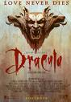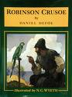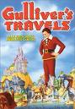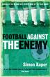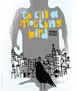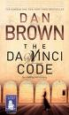
81. Dracula – Bram Stoker
82. Robinson Crusoe – Daniel Defoe
83. Gullivers Travels – Jonathan Swift
84. Football Against the Enemy – Simon Kuper
85. To Kill a Mockingbird – Harper Lee
86. The Da Vinci Code – Dan Brown
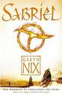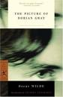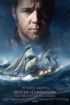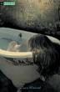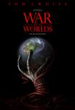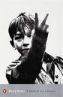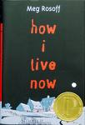87. The Other Kingdom trilogy – Garth Nix
88. The Picture of Dorian Gray – Oscar Wilde
89. Master and Commander – Patrick O'Brian
90. A Certain Slant of Light – Laura Whitcomb
91. War of the Worlds – H.G. Wells
92. A Kestrel for a Knave – Barry Hines
93. How I Live Now – Meg Roscoff
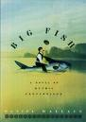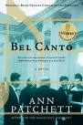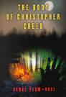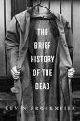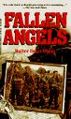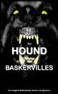
94. Big Fish – Danny Wallace
95. Bel Canto – Ann Patchett
96. The Body of Christopher Creed – Carol Plum Ucci
97. A Brief History of the Dead – Kevin Brockmeier
98. Heroes – Robert Cormier
99. Fallen Angels – Walter Dean Myers
100. The Hound of the Baskervilles – Sir Arthur Conan Doyle

These websites are all focused on reviewing teenage literature, and many give you the opportunity to submit your reviews once you've read a book!
http://www.teenreads.com
http://www.readingmatters.co.uk
http://www.cool-reads.co.uk
http://www.teenspoint.org/reading_matters/teen_reviews.asp?media=book

